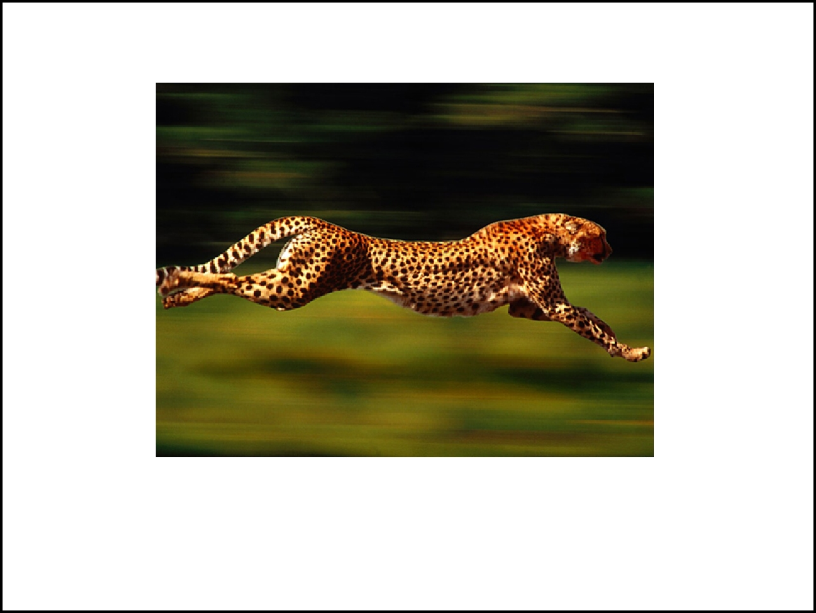

Motion
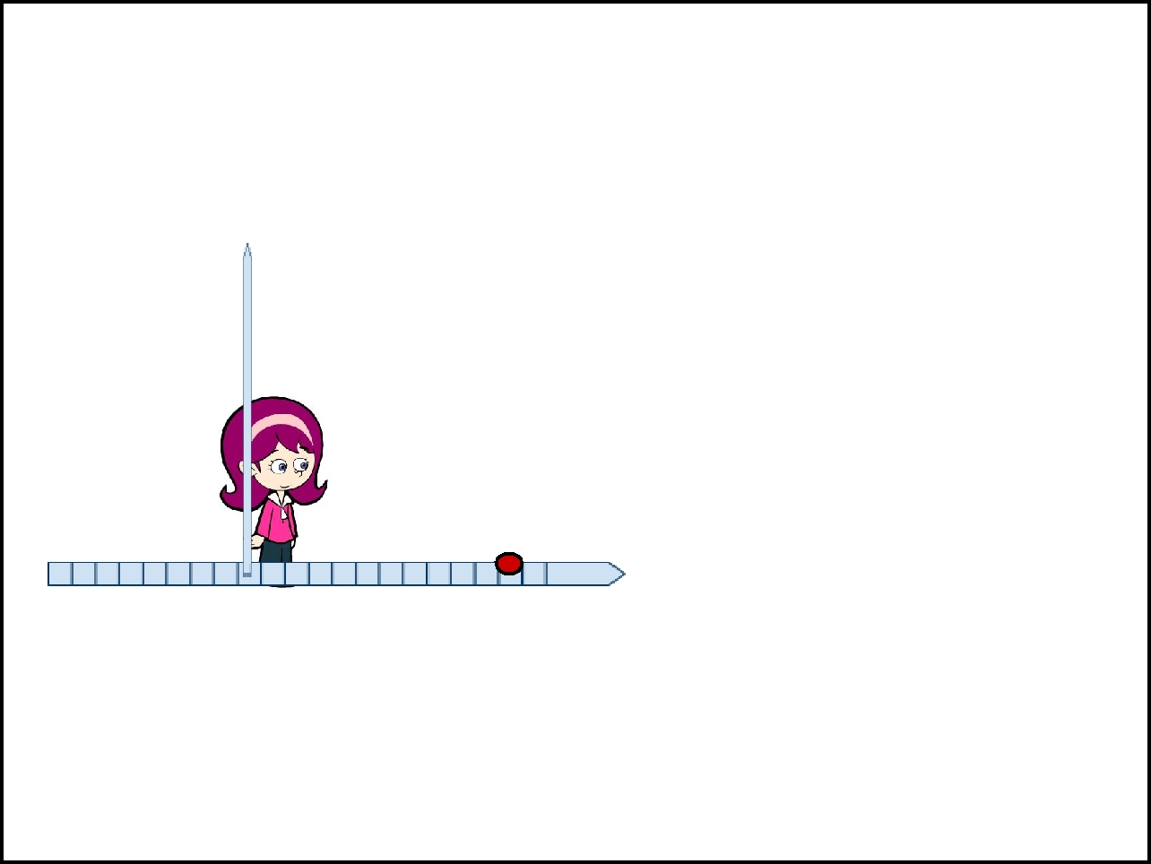
What is Motion?
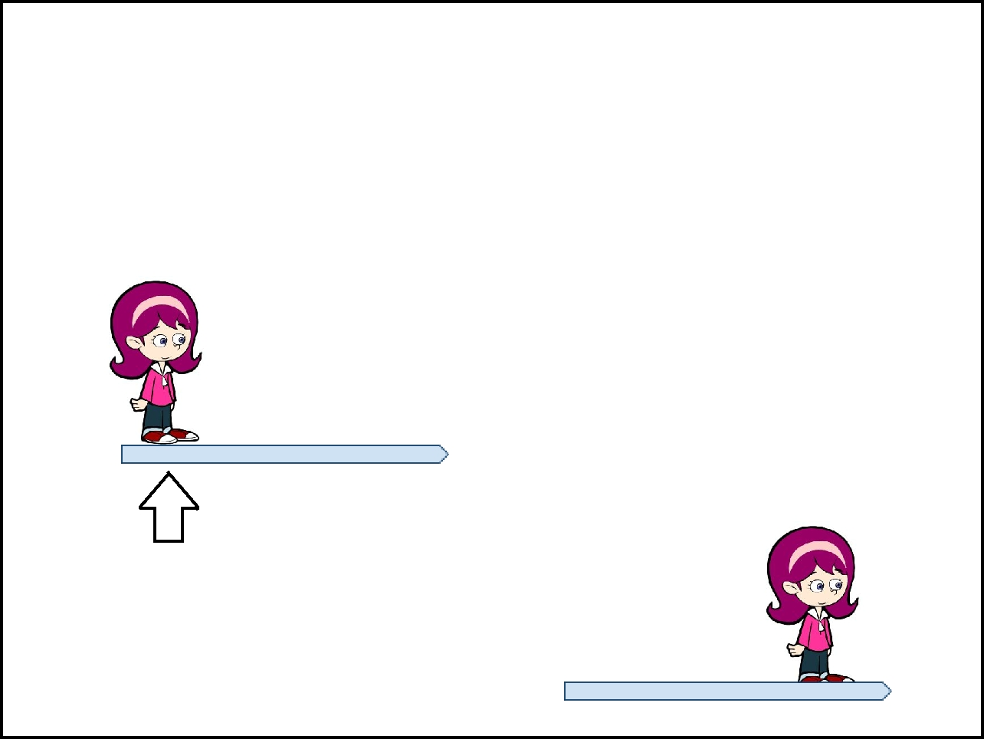
any physical _______________ or change in position or ______________, relative to a reference _____________

Movement

Reference Point

Distance = how far an object has ___________

Measured in meters, kilometers (cm or mm)

Y

Axis If each mark

represents 10

cm, what is the

distance

between the

girl and the

ball? ______

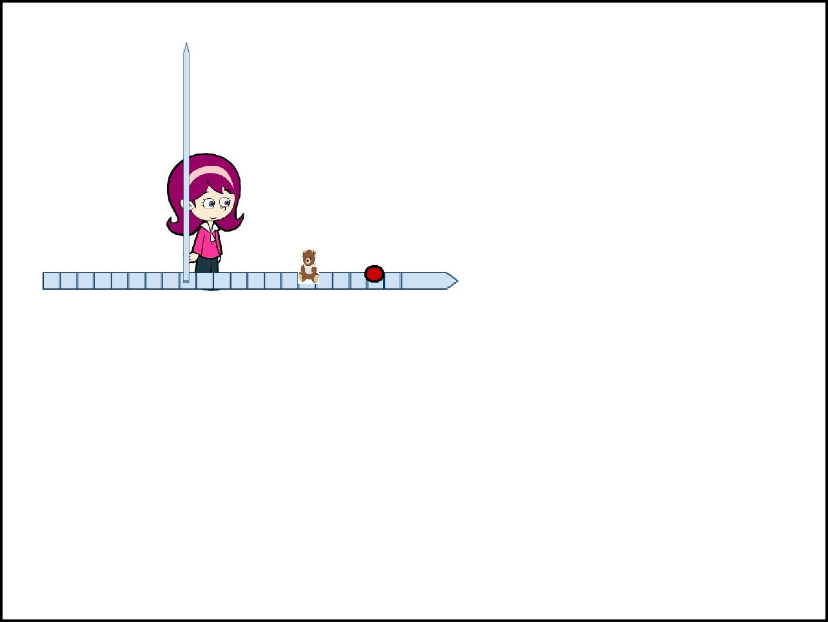

Y

Axis

X Axis

If the girl walks to the red ball, then walks backwards to the bear, how far has she traveled? _____

_

X Axis

________________ = the distance of a body's change in position from a starting point. Her final displacement is ______ from the starting point.


_______= the distance an object travels per unit of time (sec, hour, year..etc)

Speed Equation

Speed (meters/second) = distance (in meters) time (sec)

s = d
t


More practice. (Speed = distance/ time)

- An elevator travels from the first floor to the 55th floor, a distance of 210 meters, in 15 seconds. What is the elevator's speed?

- A motorcycle is moving at a speed of 40km/h. How long does it take the motorcycle to travel 120 km?

- How far does a car travel in .75 h, if it is moving a constant speed of 88km/h.

- A bicycle is traveling at 8km/h. How far does it travel in .25 h (or 15 minutes)?
A car travels a distance of 500 m in 10 sec. What is the car's speed?
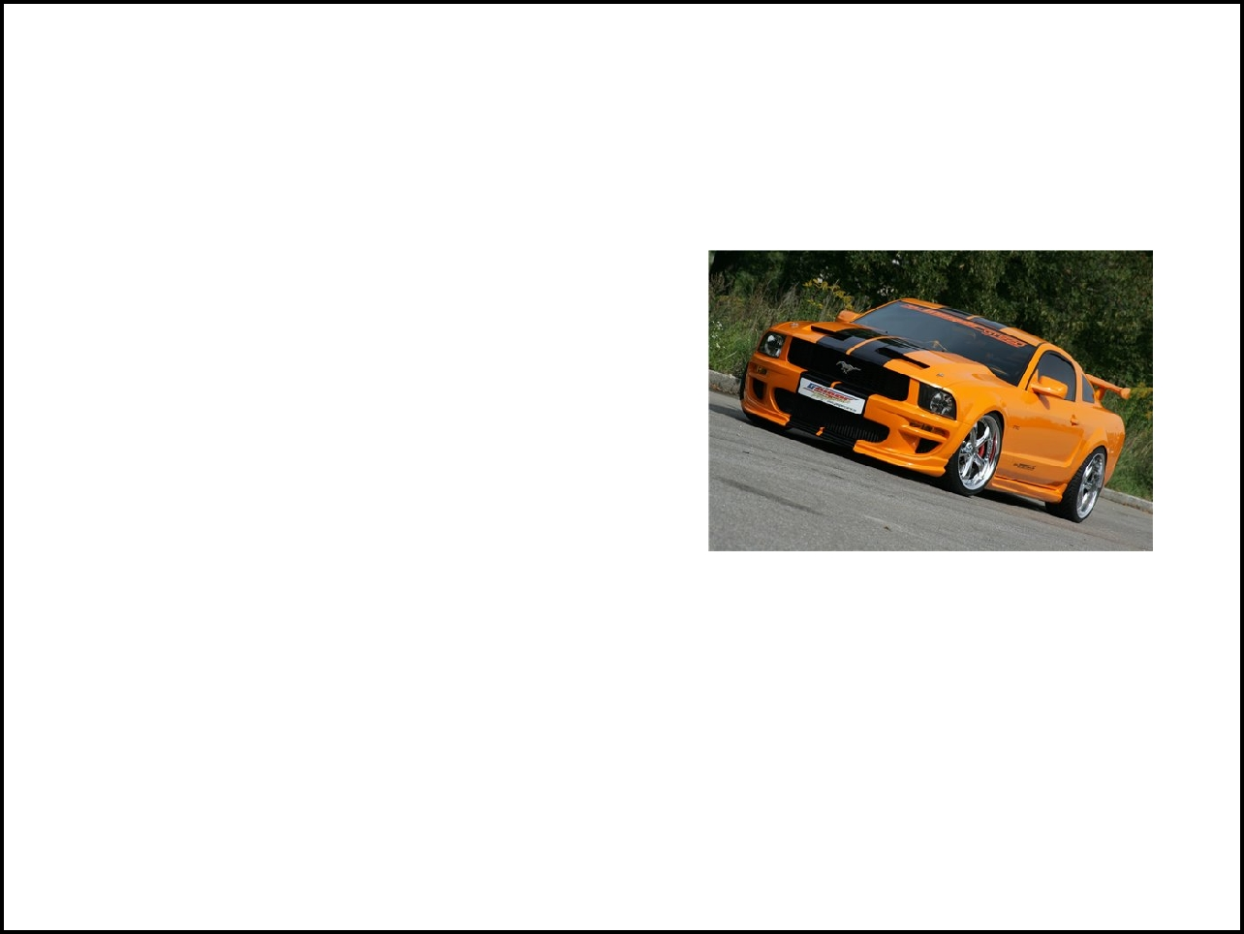
s = d/t

A second car travels a distance of 100 meters in 20 seconds. What is this car's speed?
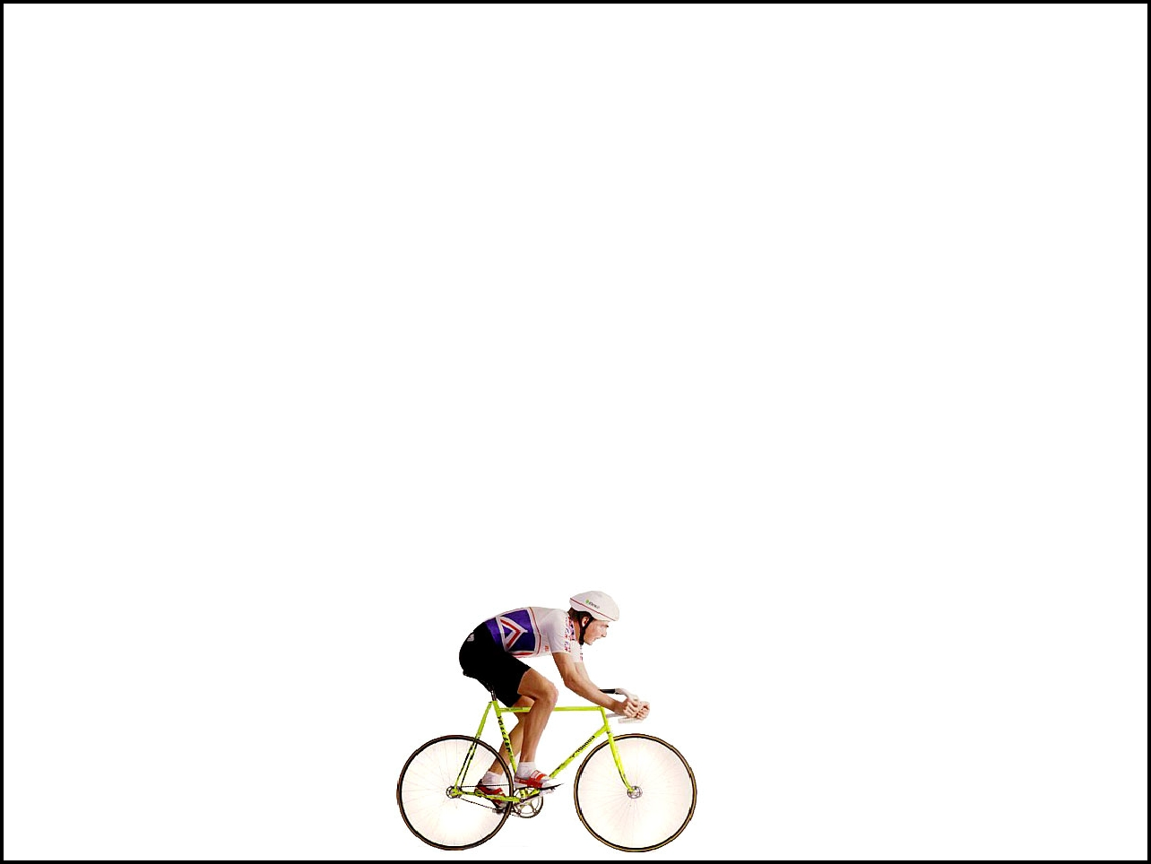

Constant Speed vs Changing Speed

Constant speed means that the speed __________________ throughout the entire distance

*Very few things can stay at a constant speed. Rather, things usually move at a constant speed for a period of time.

Imagine travelling on a bike, you start at 0 speed, then you accelerate and reach a constant speed and travel at that speed for a few blocks, then you decelerate to slow down and eventually come to a stop.
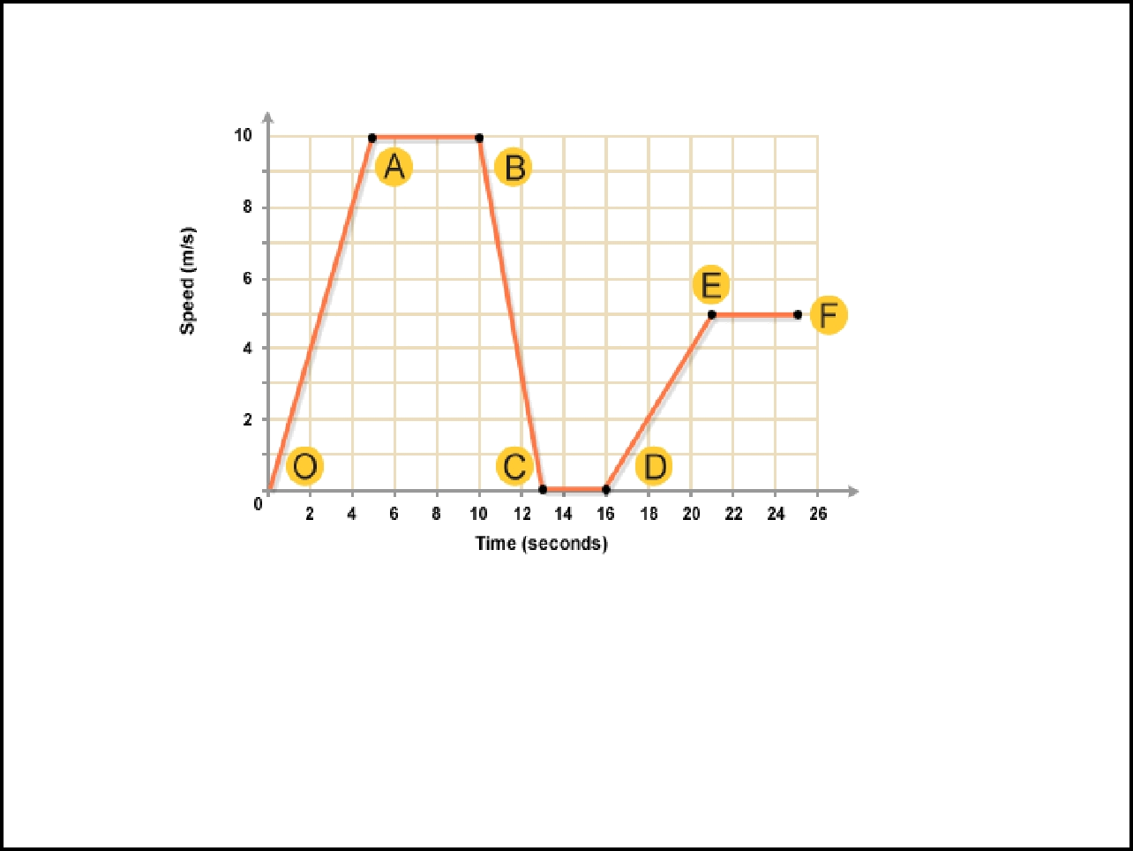
Graphs represent speeds of objects. This graph shows a bus as it travels its route.

Between what points is the bus accelerating? _____ & ____

Between what points is the bus moving at a constant speed?

_____ & _____

Between what points is the bus stopped? __________

Between what points it the bus decelerating? _________
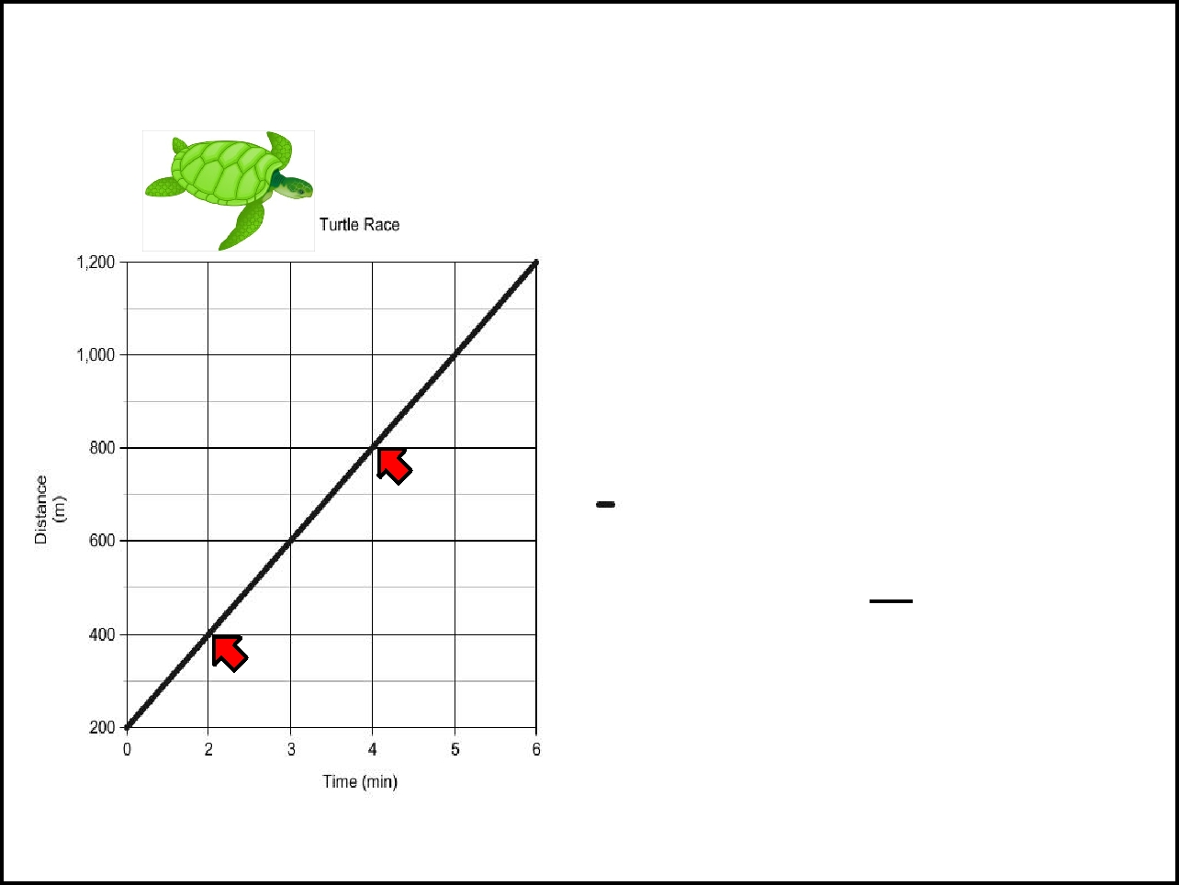

On graphs that show distance and time, the SLOPE of the line is a measure of the speed of an object.
Pick two points (X-value, Y-value) that are on the line. The easiest points to pick are points where the line crosses the grid of the graph paper.

In this example, Point 1 could be (2,400),

Point 2 could be (4,800)

Plug these two points into the following formula to calculate the slope:
Slope = Y₂ - Y₁

X₂ - X₁
Slope = 800 - 400
4- 2
Slope = 400 | = 200
2

Speed = 200 m/min

Average Speed = total distance traveled time taken
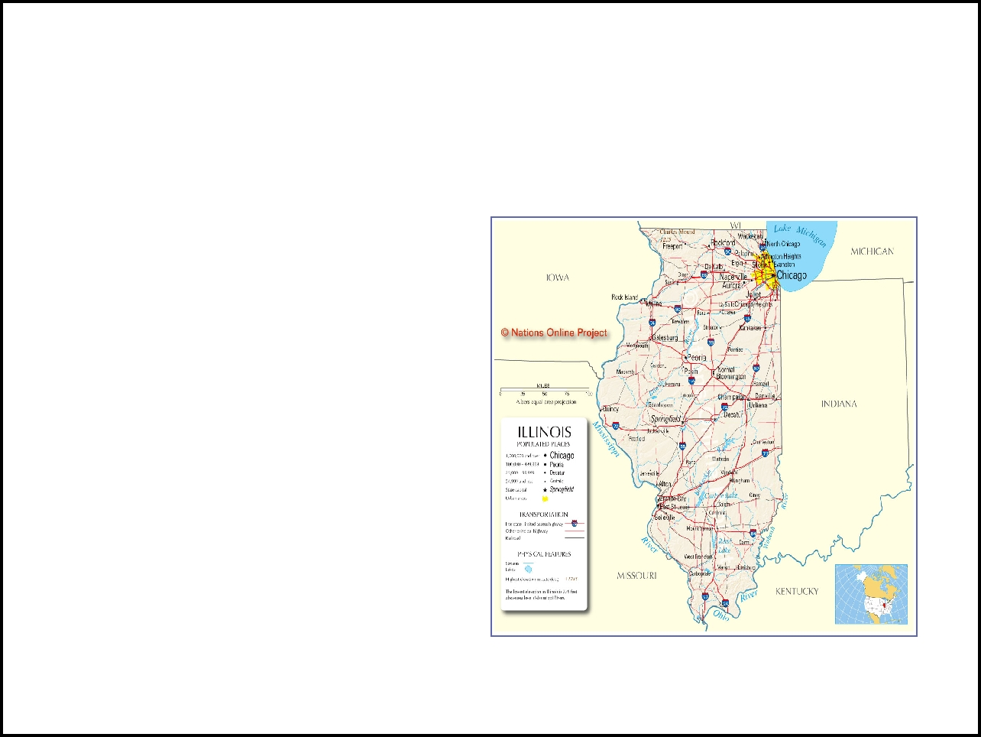
This is useful when you are trying to measure speed, and the object moved at varying speeds throughout the

trip. For instance, if you drove from here to Chicago, you might AVERAGE 60mph, even though you stopped at lights, or slowed down or when 70 at some points on your trip.
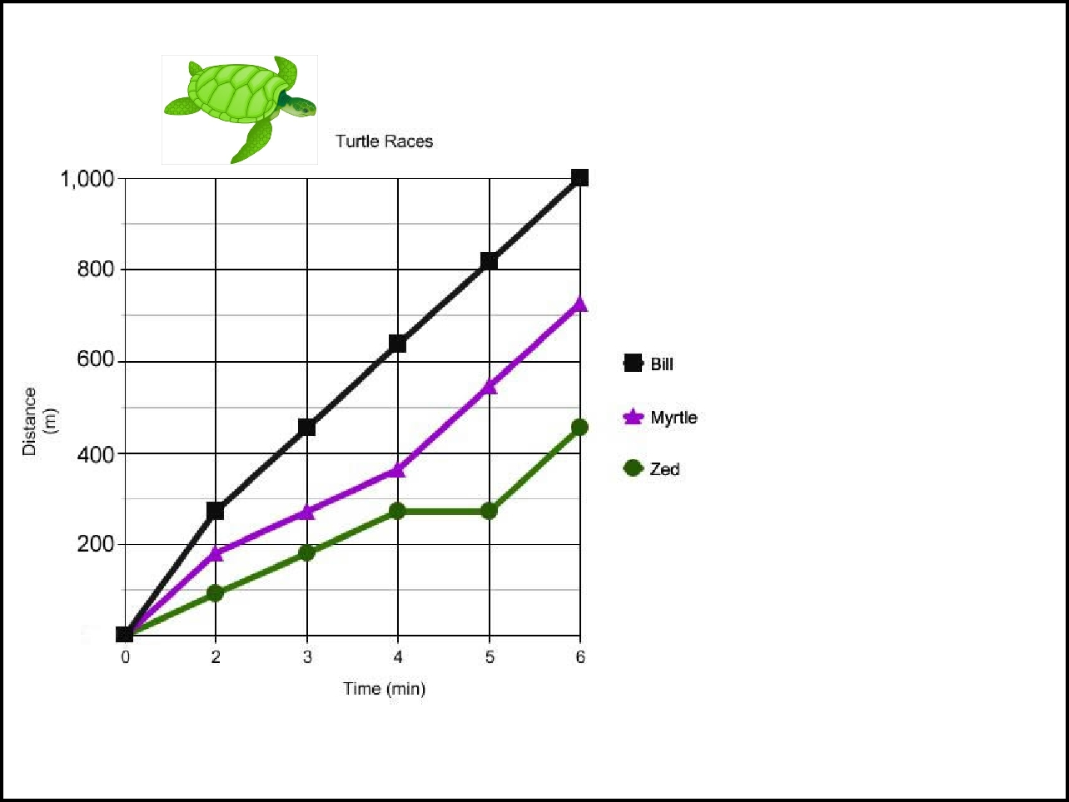

1. Calculate each turtle's speed:

Bill ______

Myrtle ______

Zed ______

2. Can you find from the graph, the point where Zed stopped and floated for a while?

3. Which turtle wins the race?

4. At what time period was Bill and Myrtle's speed the same?
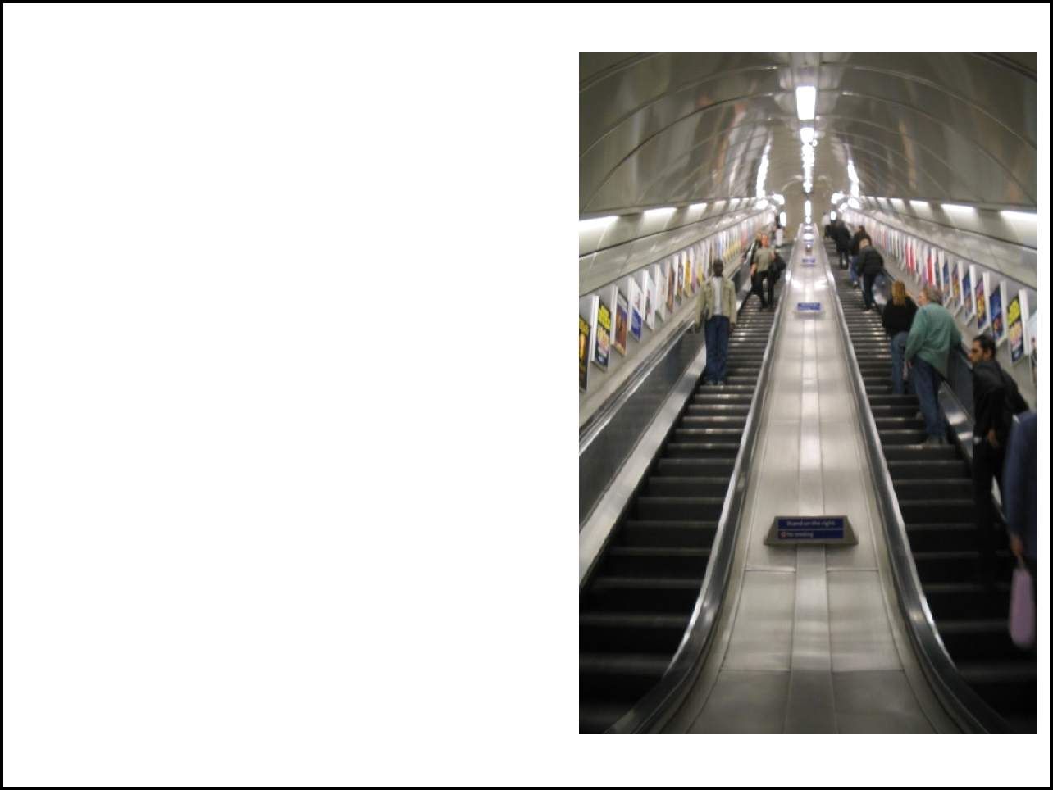
What is Velocity?

Velocity is a measure of the _________ of an object AND the ____________ it is moving in space.

On the escalator, passengers are moving at the same constant speed, but they are moving in different ________

Velocity can change even if speed is remaining constant (you just change direction)
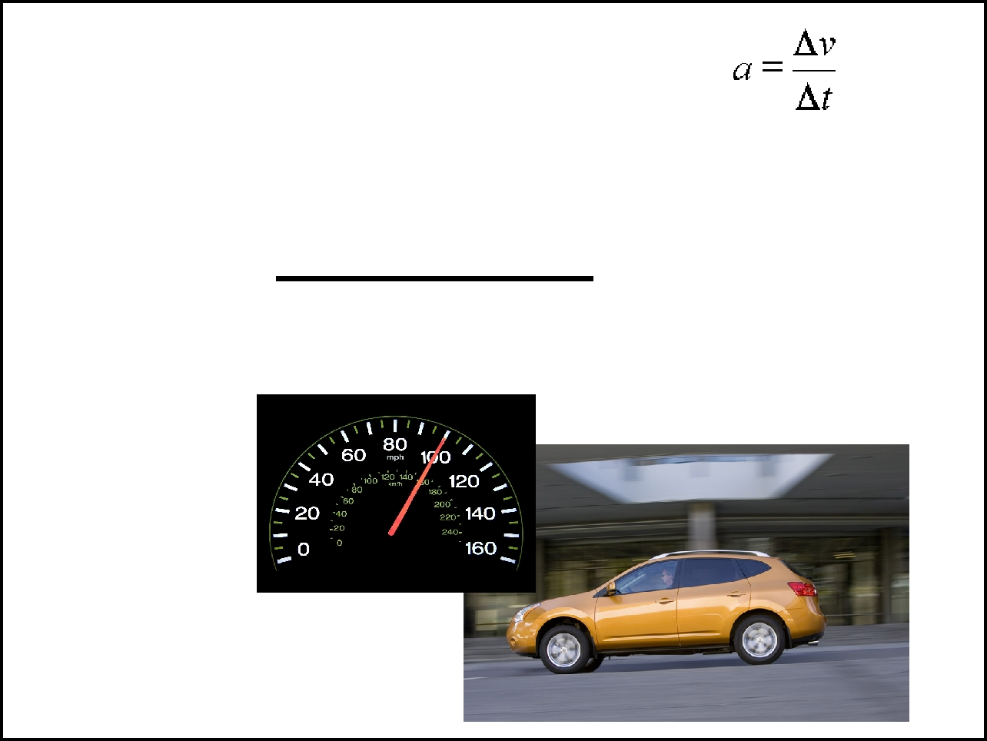

Change in velocity is often written as

the __________ indicates "change"

acceleration = change in velocity change in time

If a car moves at a constant velocity, then its acceleration is ___
Acceleration = the rate of change of velocity

Positive acceleration = _______________ Negative acceleration = ______________

Change in Velocity =

final velocity (v_{f}) - initial velocity (v_{i})

acceleration (m/s²) = (v_{f}) - (v_{i}) time
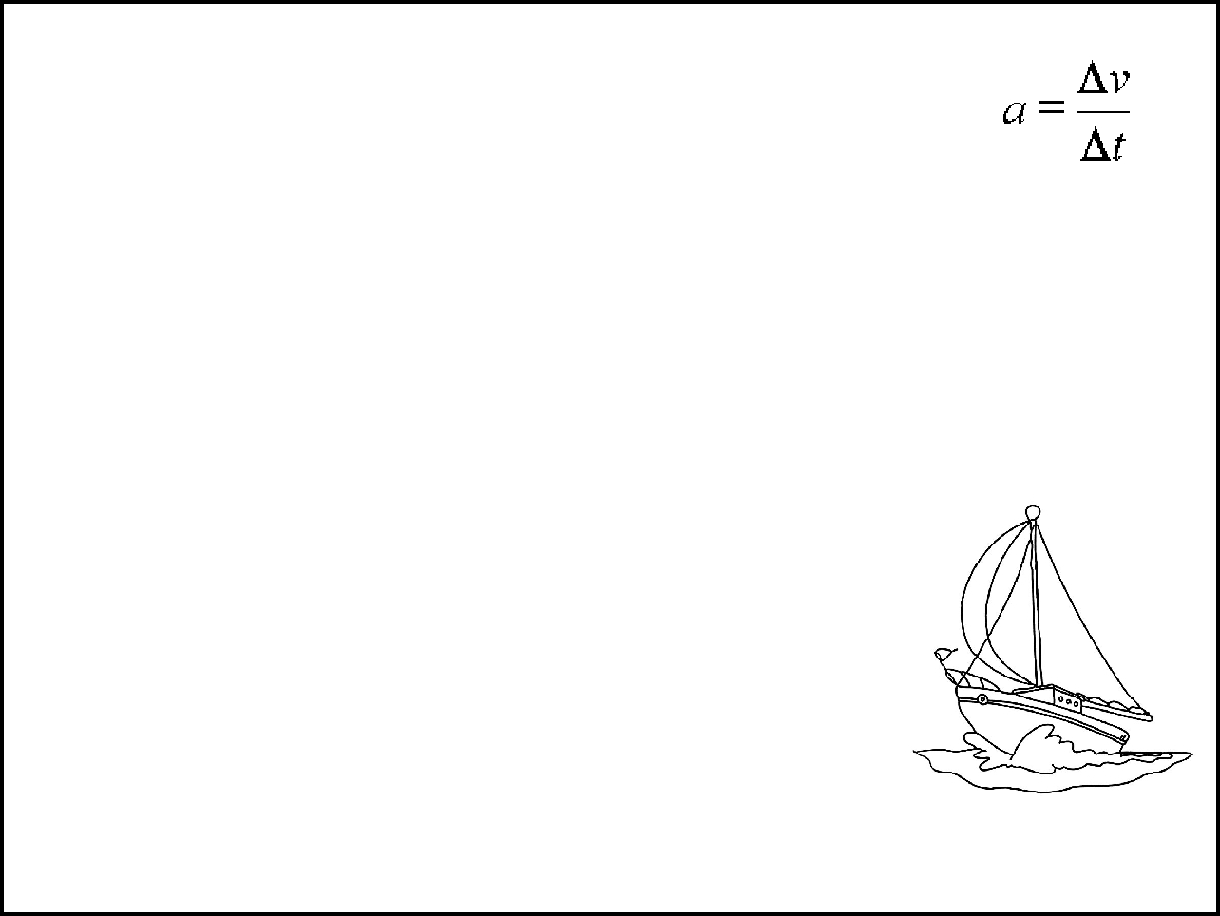

Calculations

- A plane travels in a single direction on a runway. It reaches the end of the runway in 20 seconds and its velocity is 80 m/s. What is its acceleration?

- A skateboarder is traveling at 5 m/s. He slows and comes to a stop in 15 sec. What was the

acceleration? (hint: it is a negative number)

- A sailboat is moving at 12 m/s when a gust of wind changes its velocity to 18 m/s. The wind lasts 10 seconds, at which point the boat returns to 12 m/s. For that 10 sec, what was its acceleration?

